 | Abdi İpekçi Caddesi Kaşıkçıoğlu Apt. No:42 D:2 34365 Nişantaşı İstanbul  www.artxist.com  info@artxist.com  T. +90 212 291 77 84 F. +90 212 343 69 35 | PRESS RELEASE

“x-ist @ Contemporary Istanbul’12”

x-ist is participating every year in Contemporary Istanbul (CI), which is by far the most important
international art fair in Turkey. The fair will be held between 22-25 November at the Istanbul Convention and Exhibition Center (ICEC) and the Istanbul Congress Center. At booth LK 401, x-ist will display the works of
Ali Elmaci, Ansen, Fatih Alkan, Ahmet Polat, Bahadır Baruter, Banu Birecikligil, Cem Dinlenmiş, Ceren Oykut, Ekin Saçlıoğlu, Erkut Terliksiz, Lale Tara, Nalan Yırtmaç, Nuri Kuzucan, Seda Hepsev, Sena and Serkan Adın.

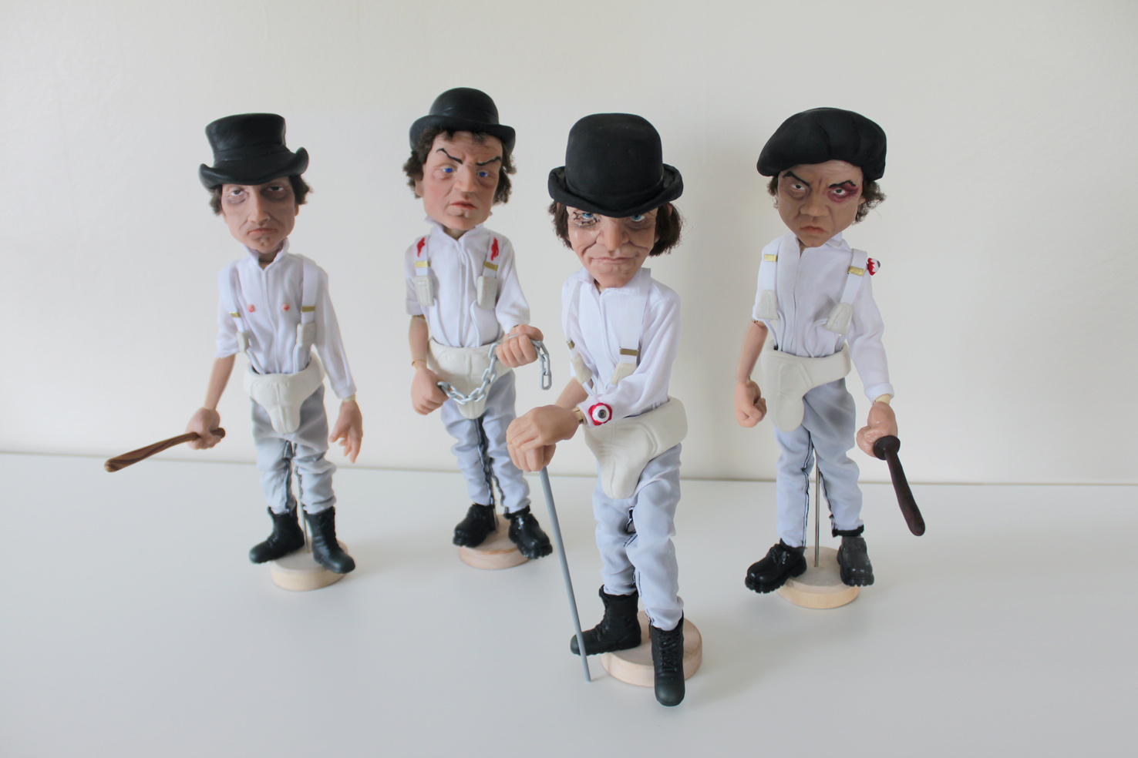

Ansen, Microbigs Series, Stanley Kubrick – Clockwork Orange characters, Oven baked clay and handmade costum, 35 cm (each), 2012

For the first time in CI'12, x-ist will have an extra project space created in its booth. This year Ansen will exhibit his sculpture series titled "Microbigs" in this space, which will be allocated each year to a different artist to implement his/her individual project. Ansen began producing the Microbigs in 2011 as hand-made small sculptures of important politicians and statesmen. This year, Ansen, in a way, pays homage to the "masters" by recreating the film directors and immortal roles of the actors as well as the characters ingrained in our memories of the `cult` movies in the World cinema. The hand-made sculptures, which vary between 30-55 cm in height, are produced using oven-baked clay, plastic and fabric. So far Ansen has featured such political figures as Obama, Pope Benedict XVI, Saddam Hussein, Tayyip Erdoğan within the "Microbigs" series. In Contemporary Istanbul’12, such characters as Anthony Hopkins as Dr. Hannibal Lecter in the movie, "Silence of the Lambs" and Marlon Brando as Don Vito Carleone in the movie, "God Father" will be displayed.

Ansen will also present a brand new digital work at the fair. In this work, titled `Intensive Care`, the artist criticizes the authority of the government over the women`s body and health through legal/institutional arrangements. The authority assumes the role of a "follower" or an "observer" and ignores the individual’s rights in this primitive practice.

At Contemporary Istanbul 2012, x-ist also introduces two new photographers. Fatih Alkan, a young talent who was born in 1983, will display his works for the first time at this fair. Alkan uses negative film and creates photographs as if shooting short films. The other new photographer at x-ist, Ahmet Polat - whose works have been exhibited at

important institutions such as Istanbul Modern and Foam Museum (Netherlands) - offers a selection from the series titled "Kemal's Dream". In this series, Polat questions how much of Ataturk’s expectations are brought to life today by portraying the Turkish youth with an objective stance, coming from his Dutch-Turkish identity.

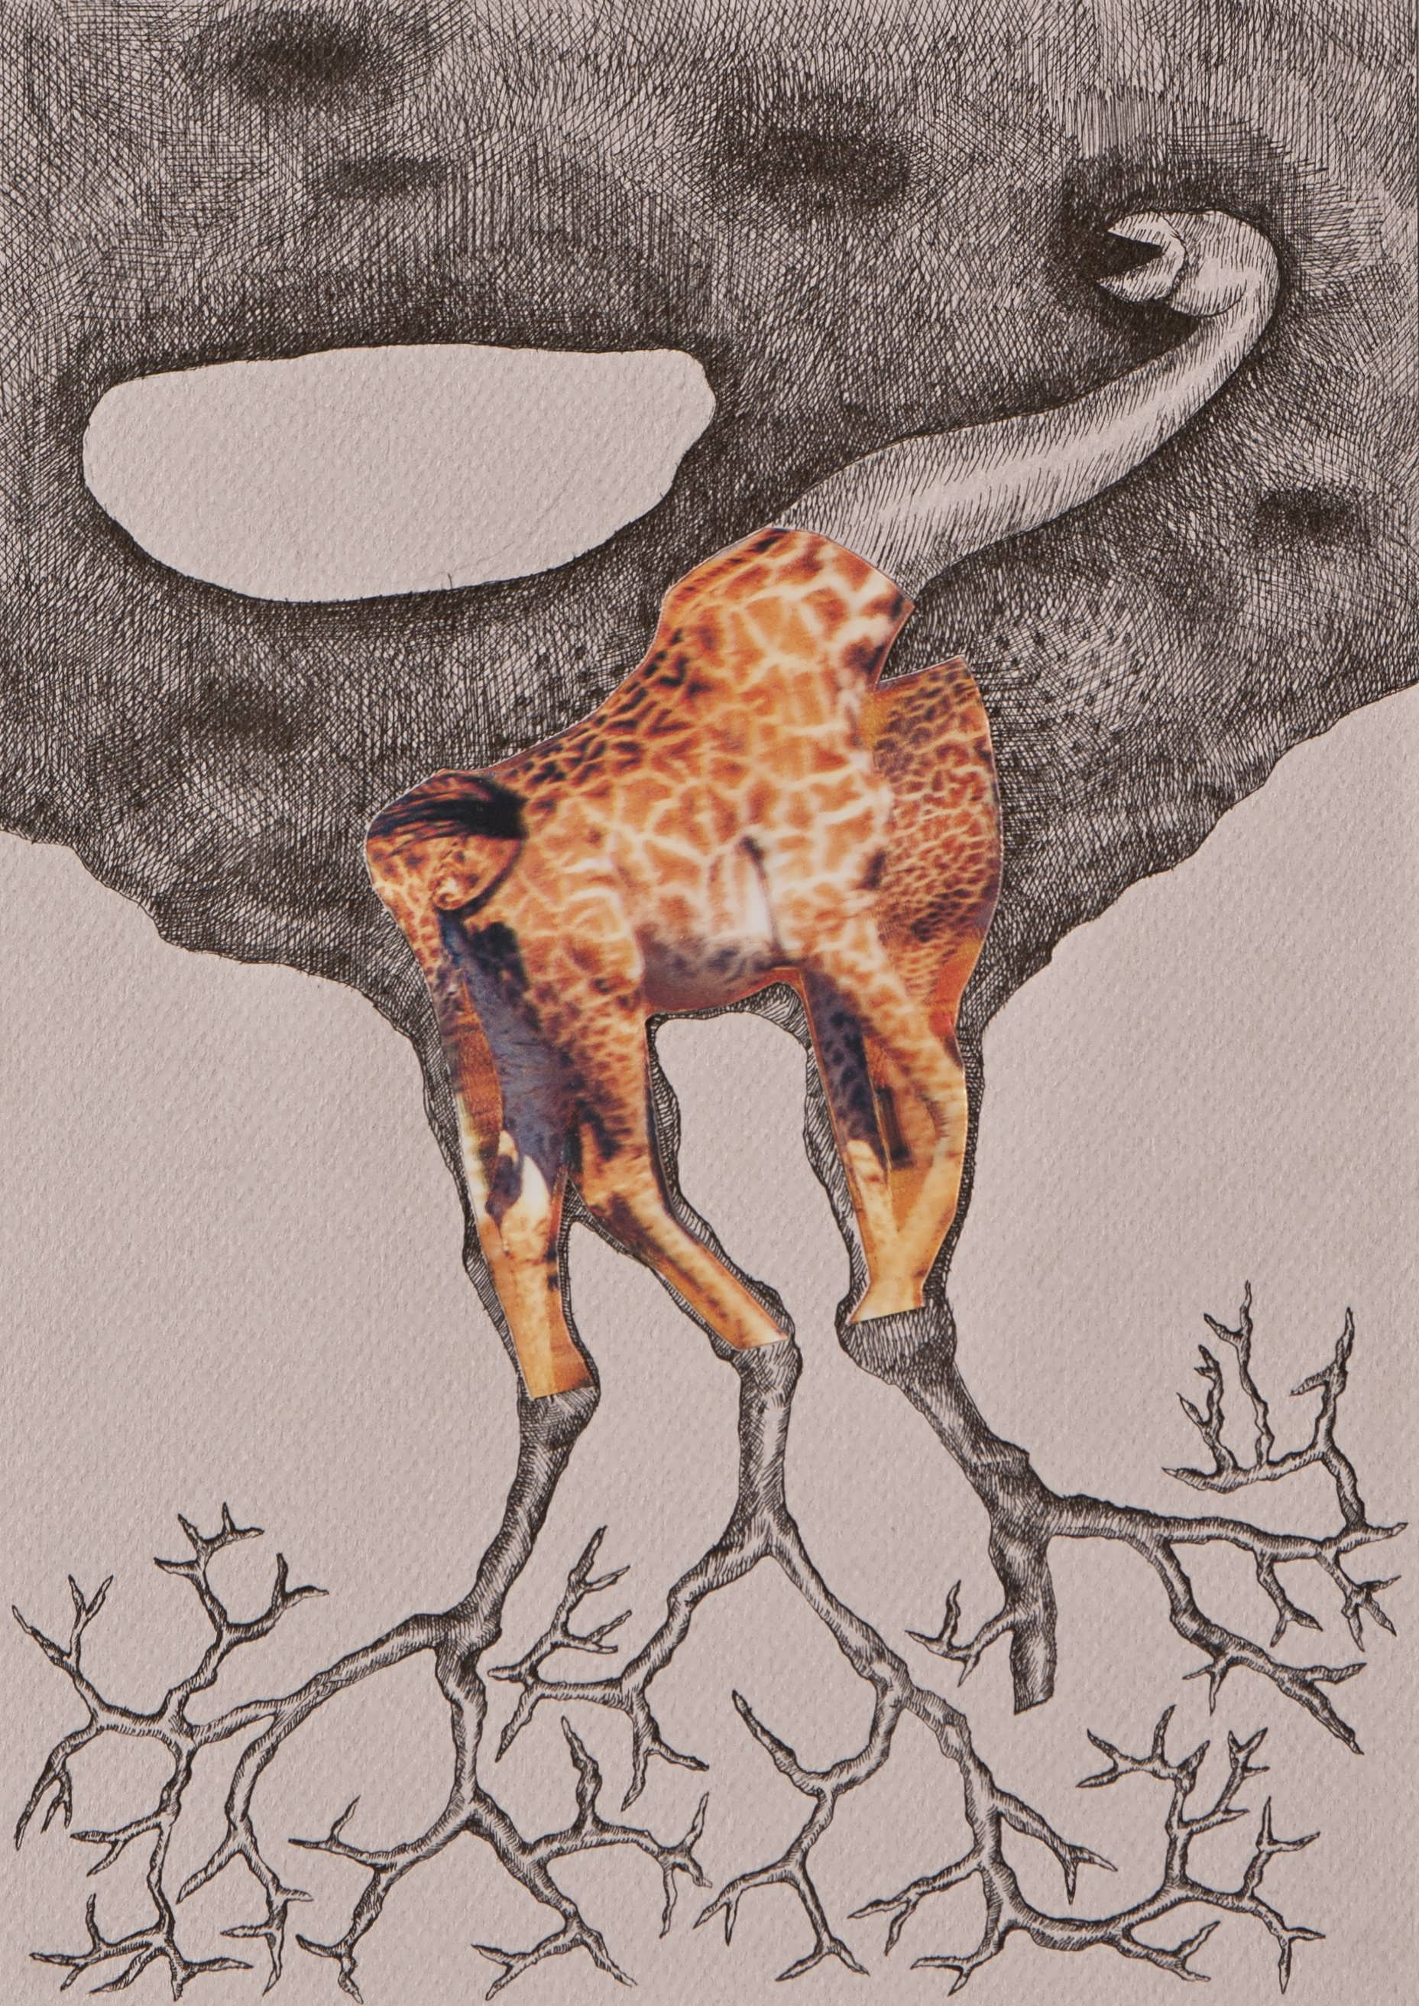
Ekin Saçlıoğlu participates in the fair with works from her new solo show “The Pothole” that opens at the same time as the fair. “The Pothole”, which can be seen at x-ist between 22 November and 15 December, deals with contemplation about the hole, and emotional and mental confrontations with it, bringing out a fiction vs. reality dilemma.

Erkut Terliksiz will showcase his drawing series for the first time at CI’12. Terliksiz will use his drawings, which are reflections of his subconscious, in his book project later on.

Ali Elmacı presents "The Conquest", the first piece of his new series, "Illustrated History of the Turks", which will be introduced at the fair for the first time. In this work, Elmacı criticizes the powerful people or institutions in metropolises for invading public space, with giant structures lacking any aesthetic or cultural value, in order to immortalize their names.

Ekin Saçlıoğlu, Underground XXIII, Hologram
collage and ink pen on paper, 30 x 21 cm, 2012

Bahadır Baruter will take part in the fair with a sequel to his recent exhibition titled "Your Family Is a Lie, Dear" shown at x-ist in September, 2012. Baruter encourages the audience to confront themselves, as he takes a counter stance to the sacred notion of family and bravely portrays all its concealed truths. Baruter depicts with an ironic approach, the true colours of the family environment, which looks warm, cozy and safe on the outside.

Lale Tara will display the first piece from her new photography series, 'Salome'. Tara adds a new one to the stories that she creates with inanimate surrogates - which represent the artist herself in front of the camera.

Seda Hepsev's new drawing series titled "Manly Care" depicts men's cosmetic products distorting the gender image they aim to represent. Stories of overthrown packaging and liquids describe the betrayal of masculine charisma with Hepsev's humorous narrative style.

Cem Dinlenmiş does not produce works aiming for the existing surface; instead, shapes the given canvas or wooden surface in accordance with his story or idea. Dinlenmiş exhibits his new work describing a series of words by using signs and presents them in the form of a plate where he combines nine panels.

Nalan Yırtmaç's work entitled "Asleep" deals with the people who are deprived from the most basic human right, the right to find shelter. The artist states that these people always pay the price of the greed of others.

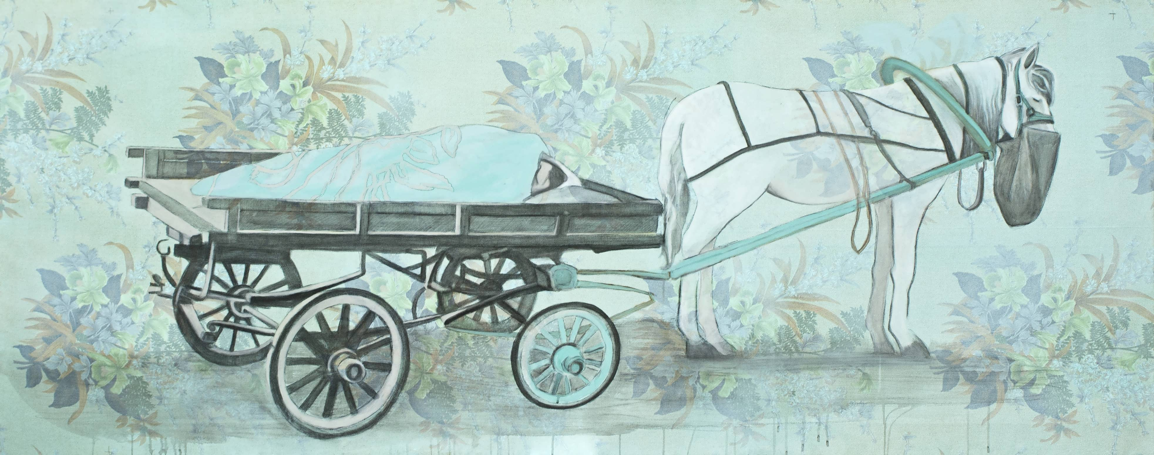

Nalan Yırtmaç, Uykuda, Kumaş üzerine kurşun kalem, akrelik ve akuarel, 90 x 240 cm, 2012

In her works “Shaman” and “Shadow” Sena paints the dark and the pure sides of the human soul, through the use of symbols and experimental material use.

Banu Birecikligil, who blends the fantastic characters of her subjective, surreal world with childhood elements, will exhibit a brand new series of paintings specially prepared for the fair.

Ceren Oykut brings together painting and cartoon in her work where she combines her personal memories with everyday scenes from Turkey.

In addition, the recent works of CANAN, Nuri Kuzucan and Serkan Adın can also be seen at the fair.

